Analysis of Login Success Message and Display username in SHP configuration :

1.Display username:

Display username filed has used for Forgot password functionality.

1. If Disabled, password will be reset based on Email field.

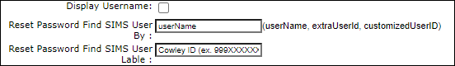

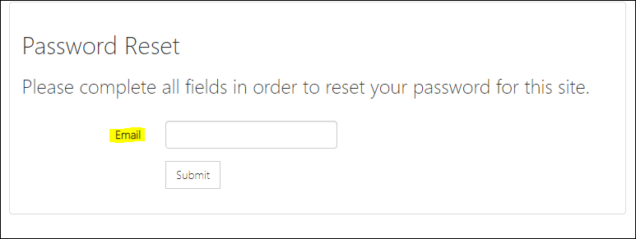

1. If enabled, password will be changed based on fields which is mentioned ‘Reset Password Find SIMS User By” field value.

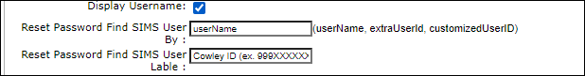

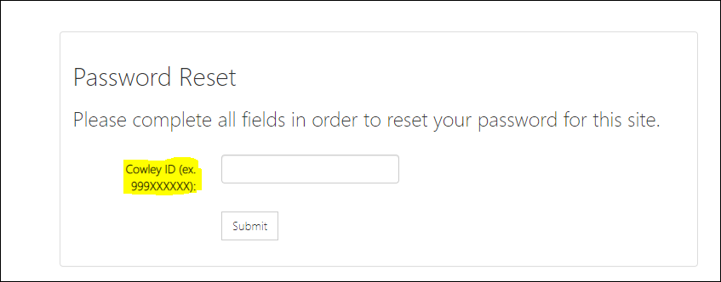

2.loginSuccessMessage :

a. If enabled, The loginSuccessMessage will be shown in “SelfHelpHome” page after login the user.

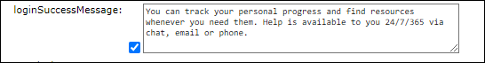

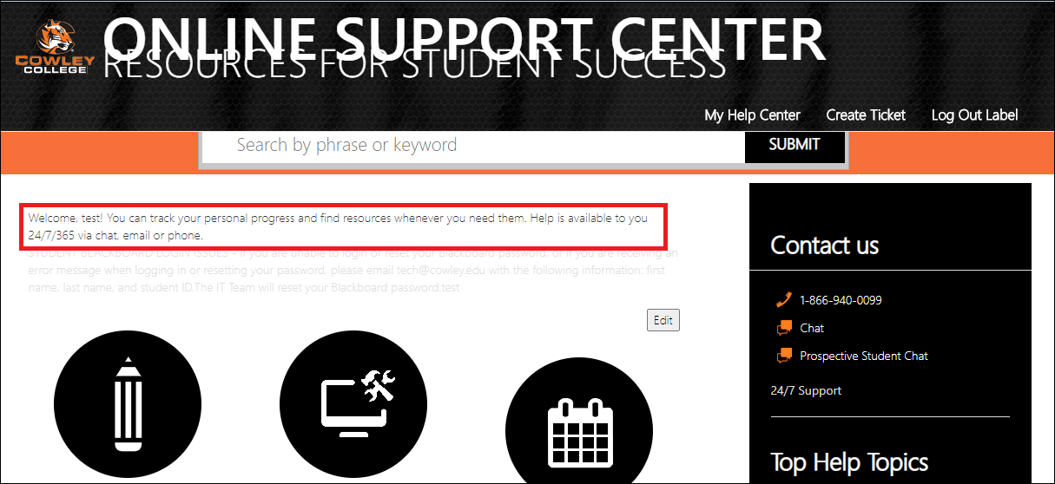

b. If disabled the “loginSuccessMessage” will not be appears in “SelfHelpHome” page.

